Append to a CSV file

# Code snippet .

Opens a CSV file in append mode and writes three numbers to it.

| 1  2  3  4 | file = open("numbers.csv", "a")  numbers = "3,4,5"  file.write(numbers)  file.close() |
| --- | --- |

Challenge .Spelling test

**Preparation**

Before you begin this activity, make sure that you have saved the file spellings.csv with your Python files.

**NOTE TO TEACHER — ADD THE LINK HERE**

**Challenge**

A teacher has a list of eight spellings that they would like to use as a test for learners. They will shout out the spelling in the classroom and the learner must type their spelling of the word into the program. The program should:

* Read the data from the spellings.csv file
* Append the data to a list
* Allow the learner to enter each spelling, one at a time
* Check if the entry matches the spelling in the list
* Record whether the learner was correct or incorrect
* Append the results data to the spellings.csv file

**NOTE:** Your **final solution** should use good programming habits and the alternative approaches covered at the start of this lesson. **Remember to comment on your code!**

**The finished CSV file should look like the example below when opened with spreadsheet software:**



**Test your code then enter it below:**

|  |
| --- |

# Explorer task . Record the learner name

At the beginning of the spelling test, it must prompt the learner for their name. This should then be held in a new column at the end of the data. The spelling test should repeat until all learners have attempted the spelling test.

An example of the finished CSV file after two learners have taken the test is below:

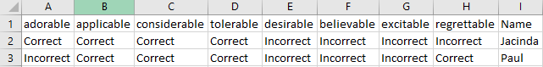

Code:

|  |
| --- |

# 